DAILY ONLINE ACTIVITIES SUMMARY

Date: |  | 26-05-2020 |  |  |  |  | Name: | Suhas Prasad Shetty
Sem & Sec |  | ₈th _{B} |  |  |  |  | USN: | 4AL16CS080
 |  |  |  |  | Online Test Summary
Subject |  |  | BDA
Max. Marks |  |  | 40 |  |  | Score |  | 14+16=30
 |  |  |  | Certification Course Summary
Course |  | Pricing and support
Certificate Provider |  |  |  | AWS |  | Duration |  |  | 30 mins
 |  |  |  |  | Coding Challenges

Problem Statement: 1) Python Program to Count the Number of Digits in a Number. \ 2) To check whether the number is palindrome or not.

Status: completed

Uploaded the report in Github | yes
If yes Repository name | suhas
Uploaded the report in slack | no

Online Test Details:
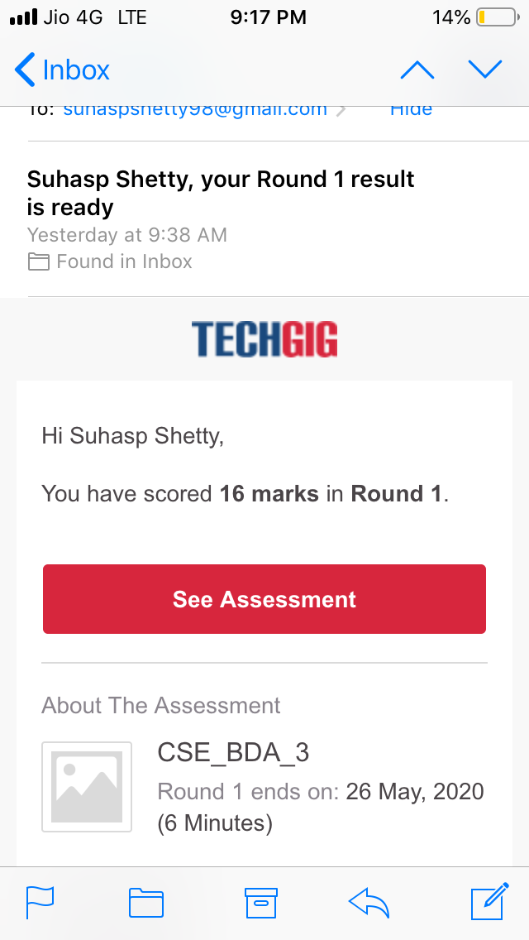
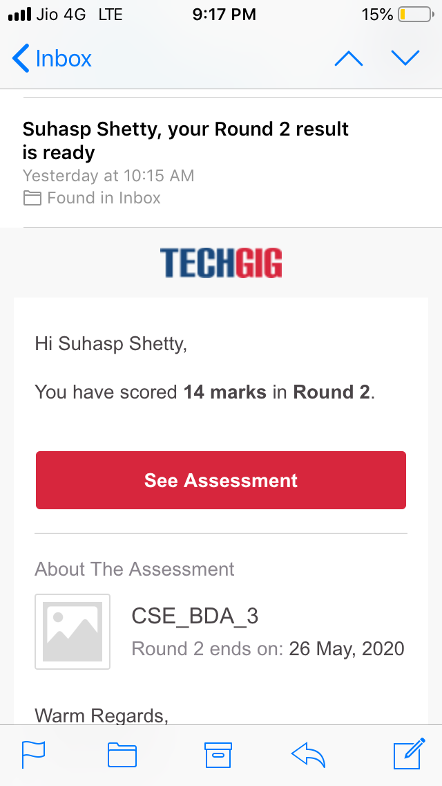

Certification Course Details
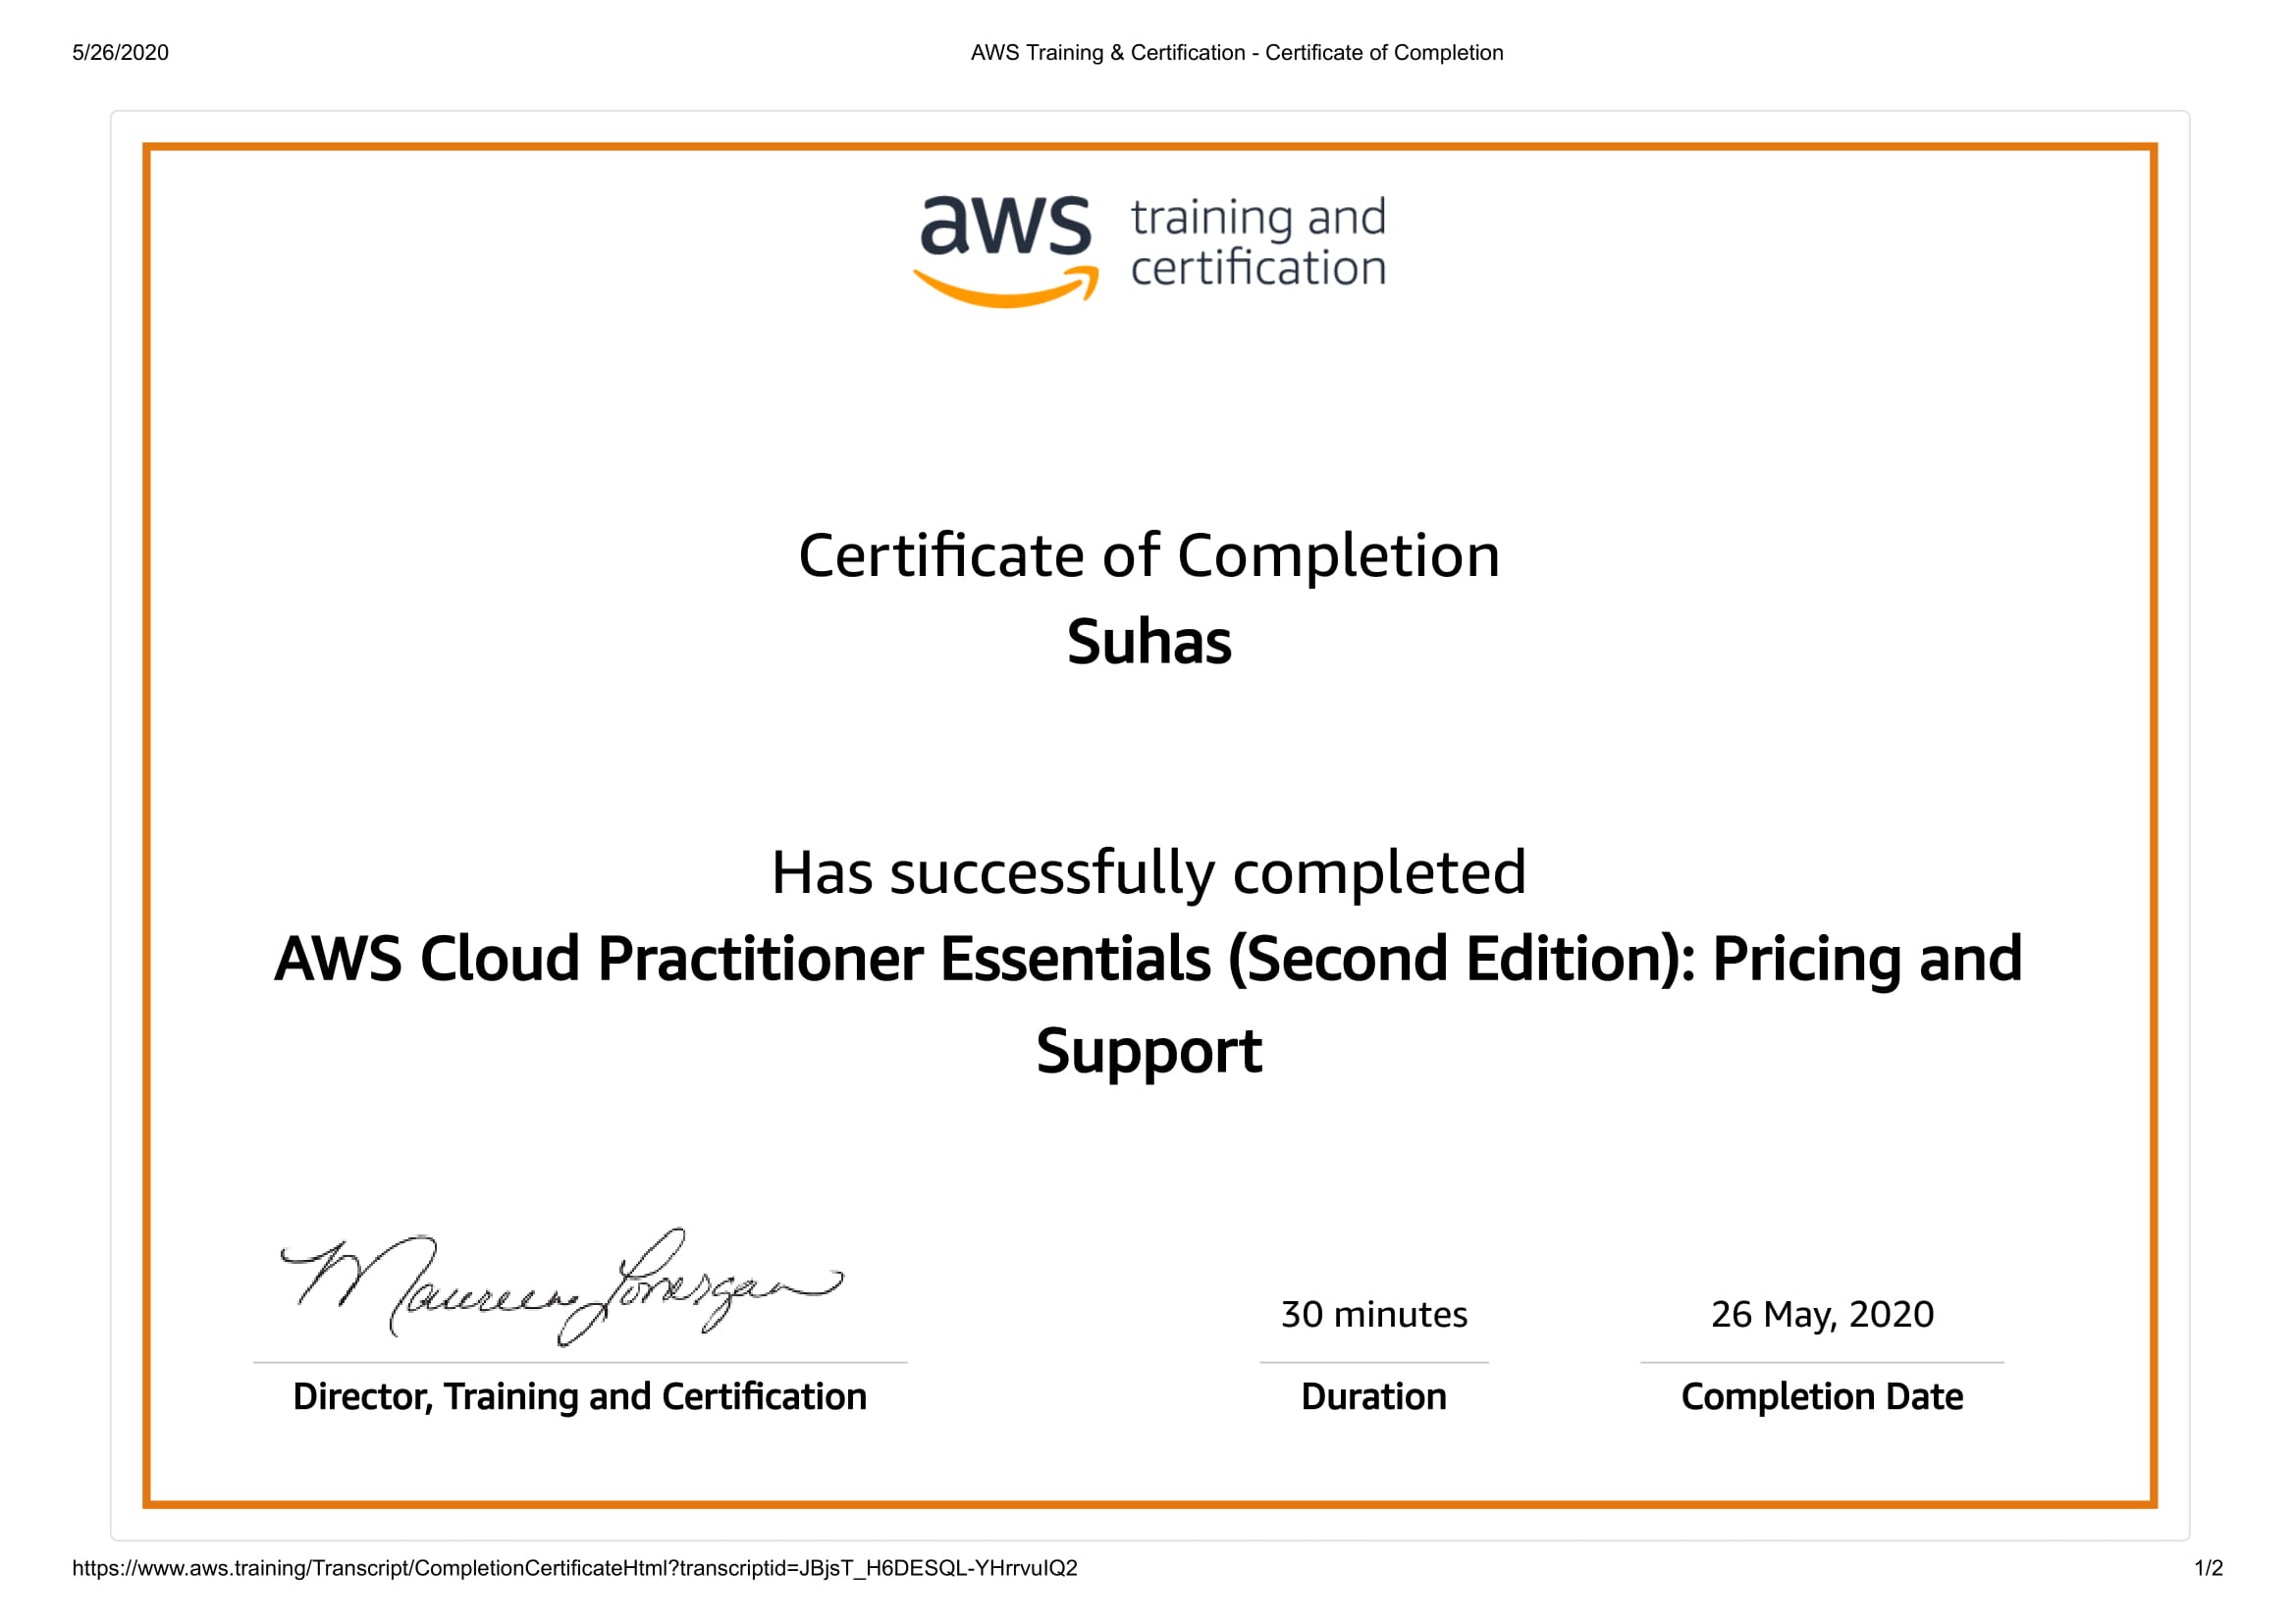

Coding Challenges Details

PROGRAM1

n=int(input("Enter number:"))

count=0

while(n>0):

count=count+1

n=n//10

print("The number of digits in the number are:",count)

Program 2

n=int(input("Enter number:"))

temp=n rev=0

while(n>0):

dig=n%10

rev=rev*10+dig

n=n//10

if(temp==rev):

print("The number is a palindrome!")

else:

print("The number isn't a palindrome!")

